

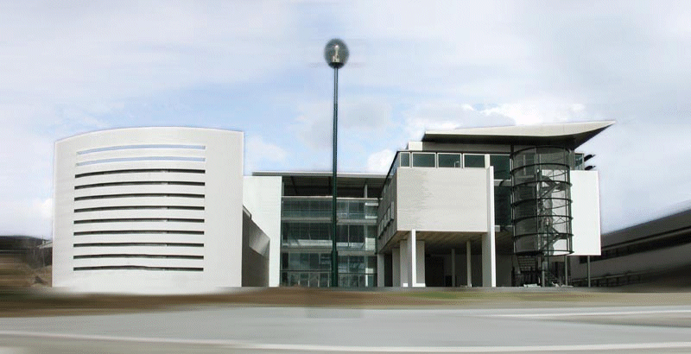

http://www.tecminho.uminho.pt/index.php

Aims and activities of the organisation

TecMinho University / Enterprise Association for the Development - was founded in 1989 as an interface of the University of Minho.
It is a non-profit organization located in the University of Minho Campus, aiming to promote the region’s development by stimulating innovation, new technologies and by promoting the transfer of knowledge between the University, the Enterprises and the society. The main purpose is to support services in the fields of innovation and deliver continuous training and strategic information. The organization specializes in innovation, technology transfer, electronic information services and development of training events, face to face and online. TecMinho has 34 experts in the fields of technology and knowledge transfer and is promoting different research projects related to innovation in all areas of the Academy, e-learning, m-learning and social networks.
TecMinho e-learning Centre was created in 2004 and provides support to the on-campus and off-campus e-learning activities, implementing online courses to different targets groups at national and international levels.
In the past two years TecMinho Knowledge Transfer Office supported the creation of 20 spin-offs (UMinho label), registered 50 Patents from University Results and worked with 120 Companies in Innovation Projects (involving UMinho Researchers and knowledge).
For the last 20 years TecMinho has been involved in different European projects related to distance learning, technology transfer and innovation.

C.2 Technical capacity: Skills and expertise of key staff involved in the project / network
.
Name of staff member | Summary of relevant skills and experience, including where relevant a list of recent publications related to the domain of the project.
Ana Dias | Currently she is the Manager of TecMinho e-Learning Centre. Besides her main role in TecMinho is to initiate, manage and evaluate EU projects and to support members of the Academy in the development and management of their EU projects related to e-learning and LLL initiatives. She has 20 years experience of working with international teams, bringing together institutions from across Europe to work together on common projects. As Coordinator of e-learning of the association she is personally in touch with senior managers, teachers and technical staff in a wide range of disciplines across different projects of the Academy. She is involved in Minho University team to develop e-learning and blended learning initiatives within UMinho Degrees, Masters and Phds.
Fátima Correia | Training manager at TecMinho for the last 10 years. Coordination of e-learning/blended learning training courses and in-class courses for organization's higher staff: pedagogical coordination relations with teachers and learners, use of different e-learning platforms and ICT technologies. EU project liaison officer. Public Relations Coordinator at TecMinho, responsible for dissemination of activities through different publics: potential learners, media, teachers, partners, organizations. Organizer of seminars, conferences and other TecMinho's events.
Marta Catarino | Director of the Technology Transfer Office of University of Minho - TecMinho, where she manages a team of 12 professionals in 3 business units: Industrial Property Management, Technology Commercialization and Entrepreneurship.  Advisor to the Vice-Rector for Innovation and Entrepreneurship, supporting the definition and implementation of Innovation and Entrepreneuship policies and manages the University's participation in private holdings.  Academic background in Engineering and post-grad studies in Industrial Property, Marketing and Strategic Management.  Extensive communication experience delivering seminars, workshops and training in more than 20 countries. Regularly invited as an expert by the World Intellectual Property Organization and is an evaluator of proof-of-concept projects for the European Research Council and for the Ministry of Education of the Czech Republic.
Pedro Silva | Technology Transfer officer at TecMinho, 10 years experience in licensing, industry liaison, project management and business development. Has successfully promoted and implemented more than 200 university-industry innovation and development projects. Has an extensive experience in science and technology commercialization, auditing companies, negotiating agreements and defining business models for technology exploitation.
Clara Silva | Entrepreneurship manager at TecMinho, coordinates the spin-off program at University of Minho, particularly in the area of technology-based new ventures. Provides business planning and development support to knowledge-intensive start-ups.
Brigita Jurisic | Brigita Jurisic is an International projects manager working in technology transfer office at TecMinho. She holds Bachelor’s degree in Psychology and Masters degree in Marketing and Strategic Management. Her experience is mainly in the business area working in institutions and consulting companies in various international projects.

